 FACT SHEET– Fall 2026

WHO: Children and Teens grades K-12th
WHAT: Building Bridges – A program for grieving children and their families
WHEN: 6 Tuesday Nights: September 8th – October 13th
WHERE: West Texas Rehab Campus – West Texas Rehab’s Conference Center 1925 University Ave, San Angelo, TX 76904
TIME: 6:30 PM – 7:30 PM
FEE: There is no charge to attend

The purpose of the Building Bridges program is to provide a unique support group for children and teens who have experienced loss through the death of someone significant in their lives. During this program, children and teens in grades K-12 will be given the opportunity to (1) recognize and express their feelings, (2) build self-esteem through validation, (3) receive guidance as they adapt to the changes in their families, and (4) develop skills in dealing with loss that they may utilize throughout life.

Running concurrently with each children’s session is an adult group created uniquely for parents and caregivers. This group is designed to help parents and caregivers have a better understanding of the changes going on with their children. An adult caregiver must remain on campus for the duration of each child session.

Referrals can be made by calling Hospice of San Angelo Bereavement Department at (325) 658-6524 or emailing mashworth@wtrc.com.

THE PARENT CONSENT FORM SHOULD BE SIGNED AND RETURNED TO THE HOSPICE OF SAN ANGELO OFFICE PRIOR TO SEPTEMBER 4th FOR THE FALL 2026 SESSION.

Please fill out a consent form for each child attending the Building Bridges sessions.

Questions/Additional Information contact: Hospice of San Angelo Bereavement Department at
(325) 658-6524 or email mashworth@wtrc.com.

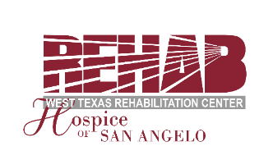
Please keep this fact sheet for your future reference. Thank you!

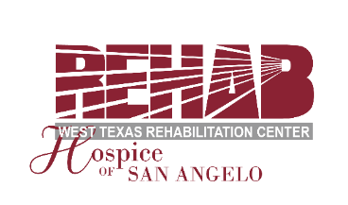

CONSENT FORM
FOR
BUILDING BRIDGES

West Texas Rehab’s Hospice of San Angelo offers a program designed to address the special needs of children and teens who have lost someone important in their lives. This program consists of six one-hour sessions. Children and teens will be given the opportunity to recognize and express their feelings and receive guidance as they are adjusting to the changes in their lives and in their families. Building Bridges is a grief support group, not professional therapy. The sessions are conducted by trained Building Bridges Volunteers.

It is my desire that my child_______________________________________________________
participate in the Building Bridges Program offered by WTRC’s Hospice of San Angelo.

Name of Parent/Guardian _____________________________________________________________

Address ______________________________________________________________ Zip _________

Phone: ____________________________ Email: _________________________________________

Child’s School _____________________________________________________ Grade ___________

Child’s Date of Birth ____________ How did you hear about us? _____________________________

Relationship of deceased to child _______________________________ Date of Death ___________

Child’s T-shirt size (please circle one): Youth S M L Adult S M L XL

Specific concerns/needs: ______________________________________________________________

___________________________________________________________________________________

___________________________________________________________________________________________________

I understand that there will be an Adult Group meeting at the same time and that an adult must remain on-site for the duration of the child’s session each week. At the close of the six sessions, if your child was referred to our program by a school counselor or professional counselor, a brief evaluation will be sent to the referring party. I hereby give permission for this evaluation to be sent to the referring party.

______________________________________________ ____________________________
Signature of Parent/Guardian Date

Please return this signed consent form to: Building Bridges
West Texas Rehab’s Hospice of San Angelo
1933 University Ave., San Angelo, TX 76904
or email to: mashworth@wtrc.com or fax to: (325) 658-8895

